**Class:** Final Year (Computer Science and Engineering)

**Year:** 2021-22 **Semester:** 1

**Course: High Performance Computing Lab**

**ESE Exam**

**22/11/2021 01.00 PM – 04.00 PM**

**Exam Seat No:**

Name: Saurabh Makarand Narkhede

2018BTECS00071

**Problem Statement 1:**

Implement Vector-Vector multiplication using OpenMP.

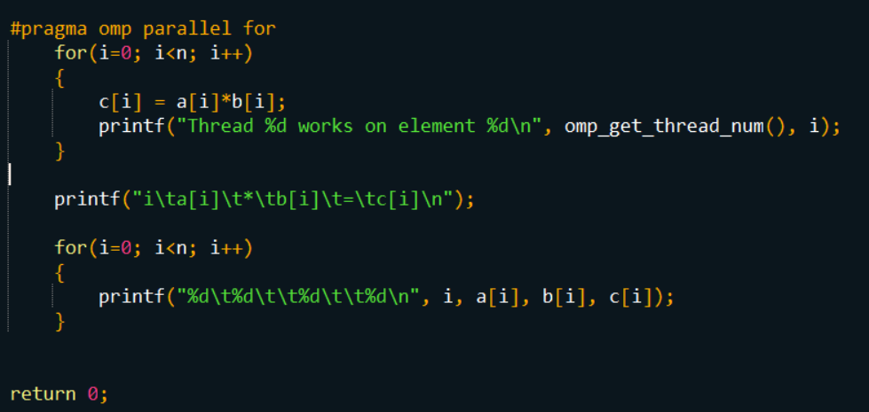

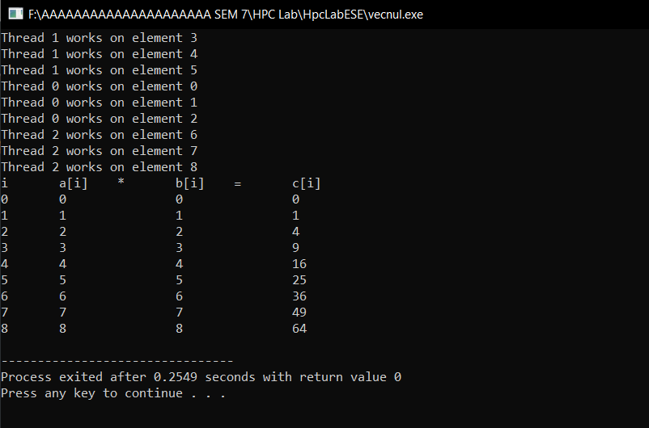

**As we can see in the screenshot of console that the thread id and element which it is executing is given. We declared 3 threads and all the three threads executing parallelly to give the result of vector-vector Multiplication.**

**Problem Statement 2:**

Implement MPI program to scatter the data from one process to other process.

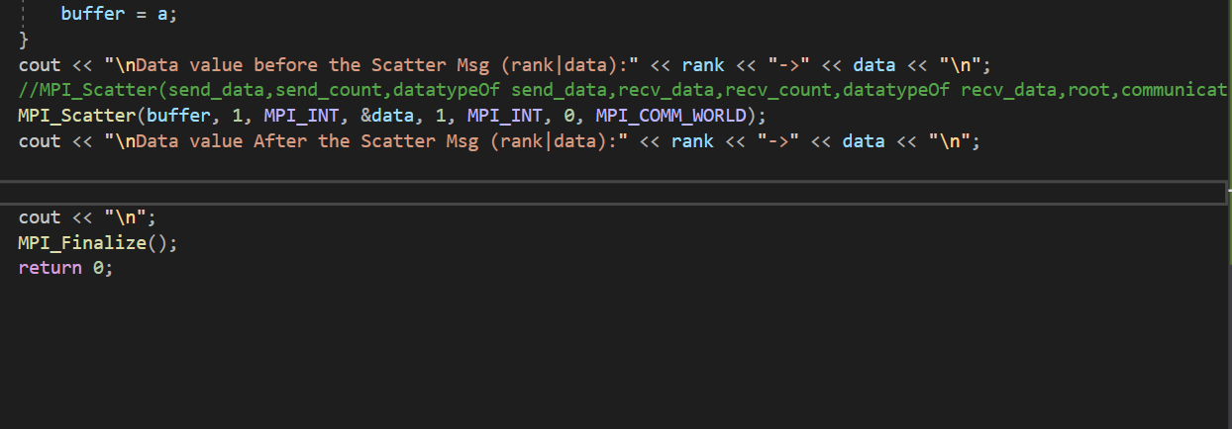

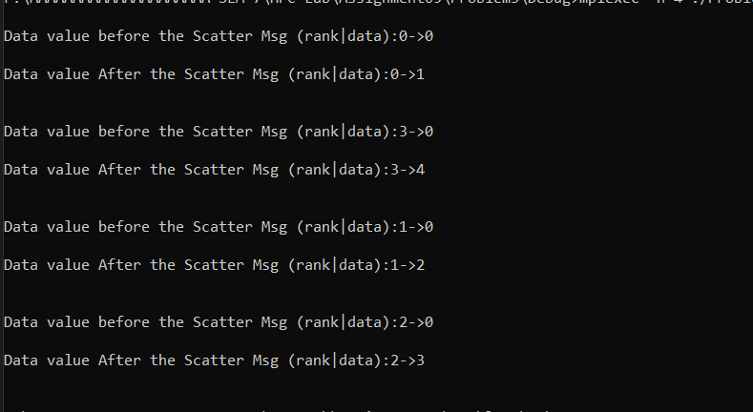

MPI_Scatter involves a designated root process sending data to all processes in a communicator. The primary difference between MPI_Bcast and MPI_Scatter is small but important. MPI_Bcast sends the same piece of data to all processes while MPI_Scatter sends chunks of an array to different processes. Check out the illustration below for further clarification.

**Problem Statement 3:**

Find Factorial of a number using CUDA.

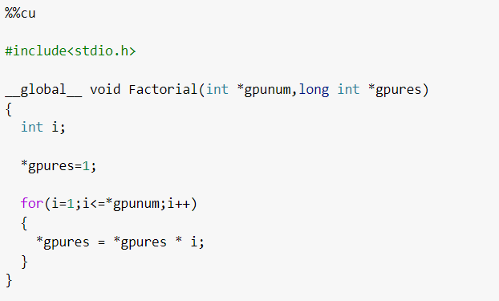

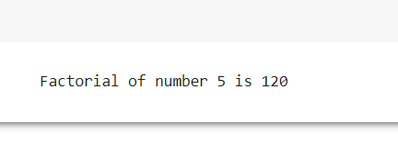

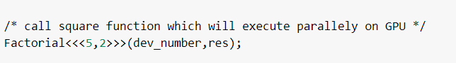

**Factorial function has declared with 5 blocks and 2 threads for each block associated with it.**

**All execute parallelly.**

**Github Link:**